Lakehouse: -
Lakehouse generally refers to a modern data architecture that combines the best features of data lakes and data warehouses:
Key Characteristics
- Data Lake Features: Stores large volumes of raw, unstructured, and semi-structured data (like JSON, images, logs).
- Data Warehouse Features: Provides structured data management, ACID transactions, and supports analytics and BI tools.
- Unified Platform: Instead of maintaining separate systems for raw data (data lake) and structured analytics (data warehouse), a lakehouse integrates both in one architecture.
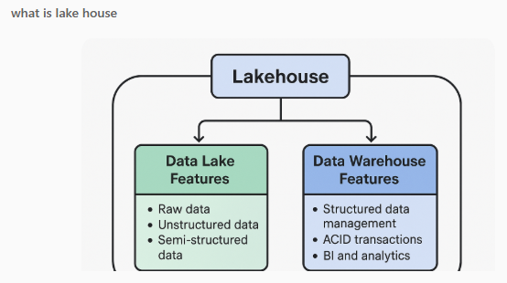
Lakehouse Architecture Diagram
The image above shows how a Lakehouse combines:
- Data Lake Features: Raw, unstructured, and semi-structured data storage.
- Data Warehouse Features: Structured data management, ACID transactions, and analytics.

Comparison Table
Aspect | Data Lake | Data Warehouse | Lakehouse
Data Types | Structured, Semi-structured, Unstructured | Structured | Structured, Semi-structured, Unstructured
Schema | Schema-on-read | Schema-on-write | Schema-on-read and write
Cost | Low (cheap storage) | High (optimized storage) | Moderate
Performance | Lower for analytics | High for BI and analytics | High (optimized for analytics and ML)
Use Cases | Big data storage, ML, raw data ingestion | Business intelligence, reporting | Unified analytics, ML, BI

Delta Lake:-
Delta Lake is an open-source storage layer that brings reliability and advanced features to data lakes, making them behave more like data warehouses while retaining flexibility. It was originally developed by Databricks.
Key Features of Delta Lake
- ACID Transactions
Ensures data consistency even during concurrent reads/writes.
- Schema Enforcement & Evolution
  - Prevents bad data from being written (schema enforcement).
  - Allows schema changes over time (schema evolution).
- Time Travel
You can query older versions of data using snapshots—great for audits and debugging.
- Unified Batch & Streaming
Handles both real-time streaming and batch data in the same table.
- Scalable & Open Format
Built on Apache Parquet, so it’s compatible with many tools.
Why Delta Lake?
- Traditional data lakes lack reliability and governance.
- Delta Lake adds transactional consistency, data quality, and performance optimizations without losing the cost benefits of a data lake.

Comparison between Delta Lake and Lakehouse:

Aspect | Delta Lake | Lakehouse
Purpose | Adds reliability and ACID transactions to data lakes | Combines data lake flexibility with data warehouse performance
Scope | Storage layer on top of data lake | Full architecture for analytics and ML
Core Features | ACID transactions, schema enforcement, time travel | Unified storage, governance, BI and ML support
Data Management | Manages data consistency and versioning | Handles structured, semi-structured, and unstructured data
Use Cases | Data engineering pipelines, ML datasets, streaming and batch processing | Enterprise analytics, BI dashboards, ML workflows
Key Difference in Simple Terms
- Delta Lake = A technology layer that improves data lakes (adds reliability, ACID, versioning).
- Lakehouse = A complete architecture that merges data lake + data warehouse capabilities for analytics and ML

